

# CSC1300: LAB 4

**You may complete this lab with a partner or not. If you choose to work with a partner, you need to notify your lab instructor now before getting started.**

## Concepts

* math expressions
* data types
* formatting output
* If/Else statements
* Relational expressions
* Validating user input

## caffeine levels – lab4a.cpp



A half-life is the amount of time it takes for a substance or entity to fall to half its original value. Caffeine has a half-life of about 6 hours in humans.

Ask the user for the caffeine amount (in mg) as input.

Validate that they entered a positive value greater than zero. If they did not, then tell the user that their input was invalid and allow them to enter in the value again.

Output the caffeine level after 6, 12, and 18 hours with two digits after the decimal point.

### example

If the input is:

**100**

the output is:

**After 6 hours: 50.00 mg**

**After 12 hours: 25.00 mg**

**After 18 hours: 12.50 mg**

Note: A cup of coffee has about 100 mg. A soda has about 40 mg. An "energy" drink (a misnomer) has between 100 mg and 200 mg.

Save your program as **Lab4a.cpp**.

## seasons – lab4B.cpp

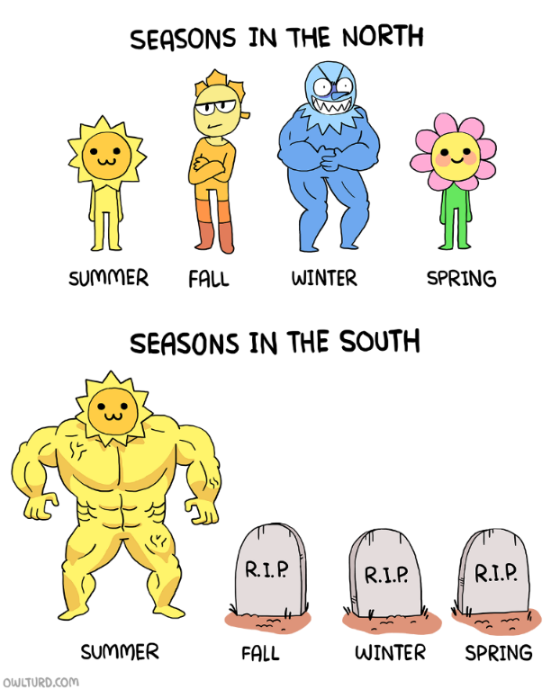

Write a program that takes a date as input and outputs the date's season.

The input is a string to represent the month and an int to represent the day.

Check if the input (both the string & int) are valid (an actual month and day).

The dates for each season are:

* **spring**: March 20 - June 20
* **summer**: June 21 - September 21
* **autumn**: September 22 - December 20
* **winter**: December 21 - March 19

### Example 1

If the input is:

**April 11**

the output is:

**spring**

### example 2

If the input is:

**Blue 65**

the output is:

**invalid**

## What to Turn In

Zip **Lab4a.cpp** and **Lab4b.cpp** together in a zip folder and then upload to Lab 4.